Material Safety Data Sheets (MSDS)

 | Manufacturer | Product | Hazard Labels
1 | AlChimica | Hyperdesmo PB-Mono | 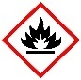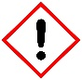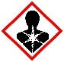
2 | Bartoline | Turpentine Substitute | 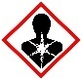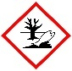
3 | BondIt | B1 Fire Rated Foam
4 | Bostik | Cementone PVA Rendabond
5 | Everbuild | 209 Liquid Mortar Tone
6 | Everbuild | Lead Mate Sealant
7 | Fischer | Anchorstar 300T Polyester Mortar | 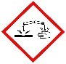
8 | Geocel | LMN Silicone Sealant
9 | Norbord | Caberfix D4 | 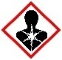
10 | Sikabond | AT Universal
11 | Sikabond | SBR
12 | Sikaflex | AT Facade
13 | Tarmac | Common Cements | 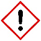
14 | Unibond | No More Nails (Original)
15 | WD-40 | Multi-use Aerosol | 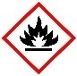
16 | Bostik/ Wickes | Mortar and Brick Cleaner
17
18
19 | Sadolin | Extra Durable Woodstain
20 | B&Q Colours | Premium Matt Emulsion

